**Uber dataset analysis**

*NAME: Sayantan Malladeb*

*CONTACT:* [*sm103@illinois.edu*](mailto:sm103@illinois.edu)

**1.)** What is the average trip distance by vendor for the given dataset?

**2.)** What is the percentage of cash vs. credit card payments for each vendor?

**3.)** What are the peak hours for trips during the day?

**4.)** How does trip fare vary based on payment type?

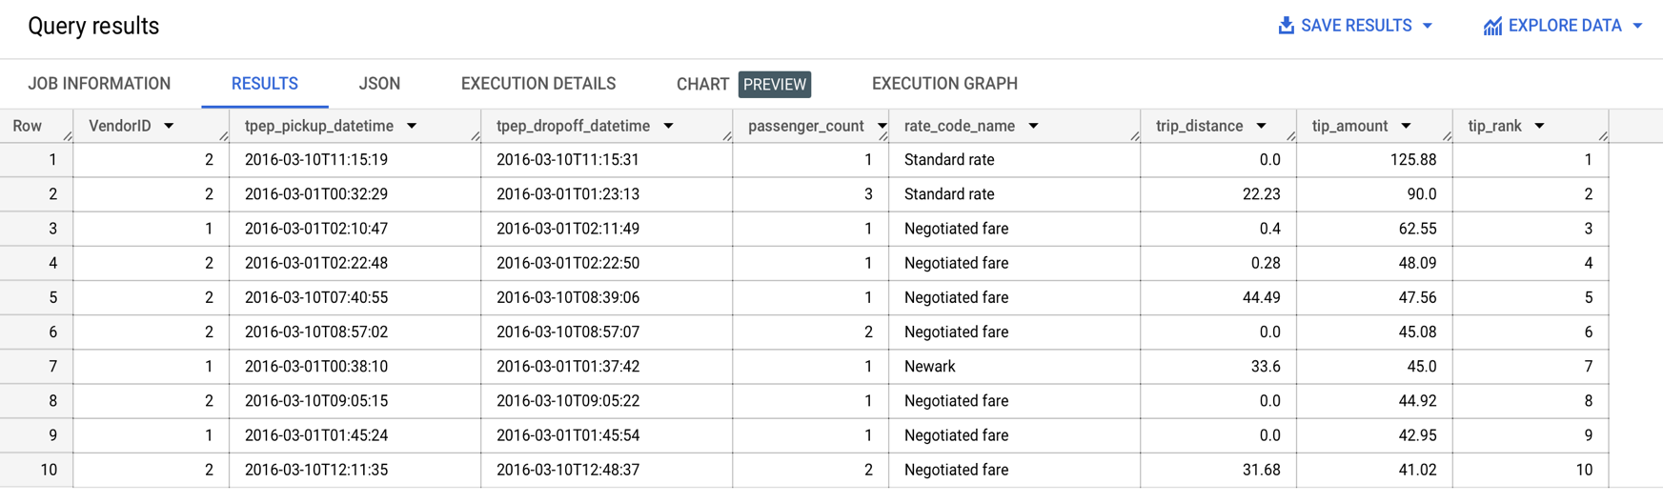**5.)** What are the top 10 trips with the highest tip amounts?

**6.)** How does the total fare amount change over time?

**7.)** What is the average trip distance for different rate codes?

**8.)** How does the tip amount vary based on the number of passengers in the trip?

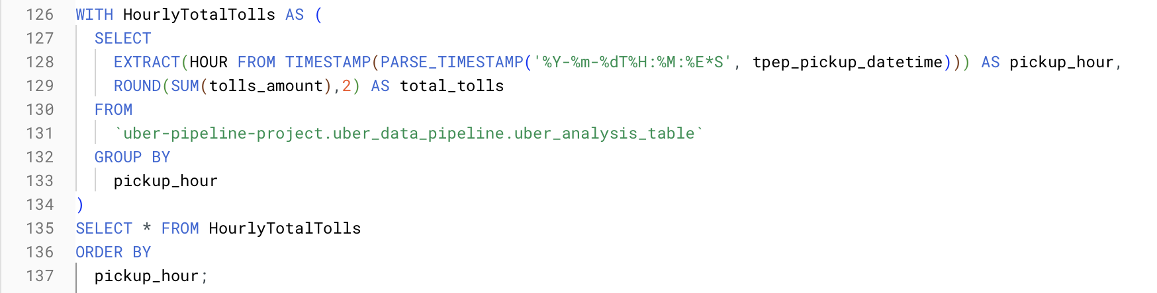**9.)** What is the overall trend in total tolls amount collected over time?

**10.)** What is the profitability by the hour?

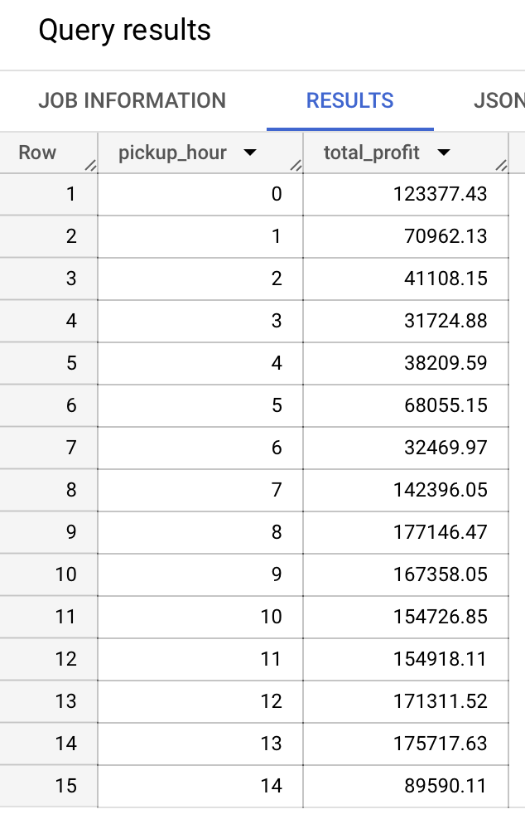

**11.)** Ride Duration Analysis:

**12.)** Geographic Analysis:

**13.)** Fare vs. Distance:

**14.)** Rate Code Analysis:

